

PROJECT REPORT
ON
PARKINSON DISEASE DETECTION USING DRAWINGS
Fundamentals of Machine Learning Lab
Subject Code: DSE 2242

Names | Registration No
RITIKA GUPTA | 220968182

Department of Data Science & Computer Applications,
Manipal Institute of Technology,
Manipal
JAN -MAY 2024

INDEX

SL No | TOPIC | PAGE NUMBER
1 | ACKNOWLEDGEMENT | 3
2 | ABSTRACT | 4
3 | CHAPTER 1  INTRODUCTION | 5
4 | CHAPTER 2  METHODOLOGY | 6
5 | CHAPTER 3  EXPERIMENTAL SETUP | 9
6 | CHAPTER 4  DATASET | 11
7 | CHAPTER 5  RESULT AND DISCUSSION | 13
8 | CHAPTER 6  CONCLUSION | 14
12 | REFERENCES | 16

ACKNOWLEDGEMENT

We would like to extend our heartfelt gratitude to our respected faculty members for their unwavering support and guidance throughout the duration of my fourth-semester project. Their expertise, encouragement, and mentorship have been instrumental in the successful completion of this project.
They provided invaluable insights and direction, which significantly contributed to the development and execution of this project. Their willingness to share their knowledge and experiences in the field of machine learning has broadened my understanding and enhanced my skills in the subject matter.
We are grateful for the time and effort they invested in reviewing my work, providing constructive feedback, and guiding me through the challenges encountered during the project. Their patience, encouragement, and dedication to our learning have been truly inspiring

ABSTRACT

This project presents a comprehensive approach to classify spiral and wave drawings using machine learning techniques. The dataset comprises images from both classes, processed to extract Histogram of Oriented Gradients (HOG) features. Multiple classifiers, including Random Forest, Support Vector Machine (SVM), Naive Bayes, and K-Nearest Neighbors (KNN), are trained and evaluated to achieve accurate classification. Hyperparameter tuning is performed for SVM and Naive Bayes classifiers using GridSearchCV to optimize model performance. Additionally, Random Forest classifiers are trained with specified hyperparameters to capture complex relationships in the data. The Voting Classifier is employed to enhance performance by combining predictions from multiple models. Through this project, we showcase the effectiveness of machine learning algorithms in analyzing complex visual data and its potential applications in various domains.

CHAPTER 1
INTRODUCTION

Image Classification Significance: Image classification is a cornerstone of computer vision, with applications spanning medical imaging to autonomous driving.

Challenging Task: Our project focuses on classifying spiral and wave drawings, presenting a challenging problem due to their intricate patterns.

Objective: Leveraging advanced machine learning techniques, we aim to develop a robust model for accurate classification of spiral and wave patterns.

Systematic Workflow: Our approach follows a systematic workflow covering data preprocessing, feature extraction, model training, hyperparameter tuning, and evaluation.

Key Libraries: Utilizing essential libraries such as scikit-learn, OpenCV, and Matplotlib facilitates efficient implementation of our methodology.

Comprehensive Framework: We strive to create a comprehensive framework for image classification tasks, emphasizing accuracy, interpretability, and scalability.

CHAPTER 2
METHODOLOGY

2.1 FLOW OF THE PROGRAM

DATA PROCESSING

Loading and standardizing the image using various tools
MODEL TRAINING

Training with different models to find the one which best suits our problem statement

MODEL EVALUATION:
Evaluate each classifier's performance using accuracy scores.

HYPERPARAMETER TUNING:
Using different hyperparameters so as to achieve better accuracy and avoid over or under-fitting

.
ENSEMBLE LEARNING:
Train a Voting Classifier by combining predictions from multiple models

TESTING THE MODEL:
Evaluation of the model’s prediction on testing set

RESULT ANALYSIS:
Analyse the accuracy and performance of each classifier.

2.2 Methodology behind each step

- Data Preprocessing
  - Load images from directories.
  - Resize images to a standardized size.
  - Convert images to grayscale.
  - Extract Histogram of Oriented Gradients (HOG) features.
- Model Training
  - Train Random Forest classifier.
  - Train Support Vector Machine (SVM) classifier.
  - Train Naive Bayes classifier.
  - Train K-Nearest Neighbours (KNN) classifier.
- Hyperparameter Tuning
  - Perform hyperparameter tuning for SVM classifier using GridSearchCV.
  - Perform hyperparameter tuning for Naive Bayes classifier.
- Model Evaluation
  - Evaluate each classifier's performance using accuracy scores.
  - Compare and analyse the accuracy of individual classifiers.
- Ensemble Learning
  - Train a Voting Classifier by combining predictions from multiple models.
  - Evaluate the Voting Classifier's performance.

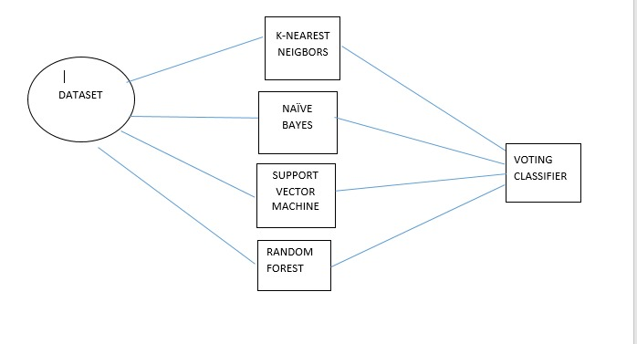

Result Analysis
  - Analyse the accuracy and performance of each classifier.
  - Identify strengths and weaknesses of different models.
  - Determine the most effective model for classifying spiral and wave drawings.

CHAPTER 3
EXPERIMENTAL SETUP

Jupyter Notebook, an interactive computing environment, serves as a cornerstone in our experimental setup, facilitating various aspects of our project:
- Development and Documentation: Jupyter Notebook provides an intuitive interface for writing, executing, and documenting code in a structured manner. It allows us to combine code, visualizations, and explanatory text in a single document, fostering clarity and reproducibility in our experimental workflow.

- Presentation: With support for Markdown and HTML, Jupyter Notebook enables the creation of rich, interactive presentations. We can seamlessly integrate code snippets, visualizations, and explanatory text to communicate our findings effectively.

In our experimental setup, we leverage several Python libraries to streamline the development, analysis, and presentation of our classification framework. The key libraries used include:
- scikit-learn:
  - scikit-learn is a versatile machine learning library that provides a wide range of algorithms for classification, regression, clustering, and more.
  - We utilize scikit-learn for model selection, training, hyperparameter tuning, and evaluation. Its comprehensive set of functionalities enables us to experiment with various classifiers and optimize their performance.

- OpenCV (cv2):
  - OpenCV is a popular computer vision library that offers extensive tools and functions for image processing, feature extraction, and computer vision tasks.
  - We employ OpenCV for loading images, resizing them to a standardized size, converting them to grayscale, and extracting Histogram of Oriented Gradients (HOG) features. These processed images serve as inputs to our machine learning models.

- Matplotlib:
  - We utilize Matplotlib for visualizing data distributions, model performance metrics, and other relevant insights. Its flexibility and customization options allow us to create informative and visually appealing plots to analyse our experimental results.

- GridSearchCV (from scikit-learn):
  - GridSearchCV is a utility in scikit-learn that performs hyperparameter tuning using an exhaustive search over a specified parameter grid.
  - We employ GridSearchCV for optimizing hyperparameters of selected models, such as Support Vector Machine (SVM) and Naive Bayes classifiers. This enables us to identify the best combination of hyperparameters for improving model performance.
These libraries, combined with the capabilities of Jupyter Notebook, form the foundation of our experimental setup. They provide the necessary tools and functionalities to develop, evaluate, and refine our classification framework efficiently. Through their seamless integration, we can explore, analyse, and interpret complex data, ultimately leading to the enhancement of our classification system.

CHAPTER 4
DATASET

The dataset serves as the foundation for training, validating, and testing our classification models. Its diverse composition, balanced distribution, and preprocessing steps contribute to the robustness and generalization capabilities of our classification framework. Through careful analysis and preprocessing of the dataset, we aim to develop a reliable and accurate classification

Inspiration
- What patterns are present for Parkisons patients?
- Are there small, robust features that can be used for diagnosis?
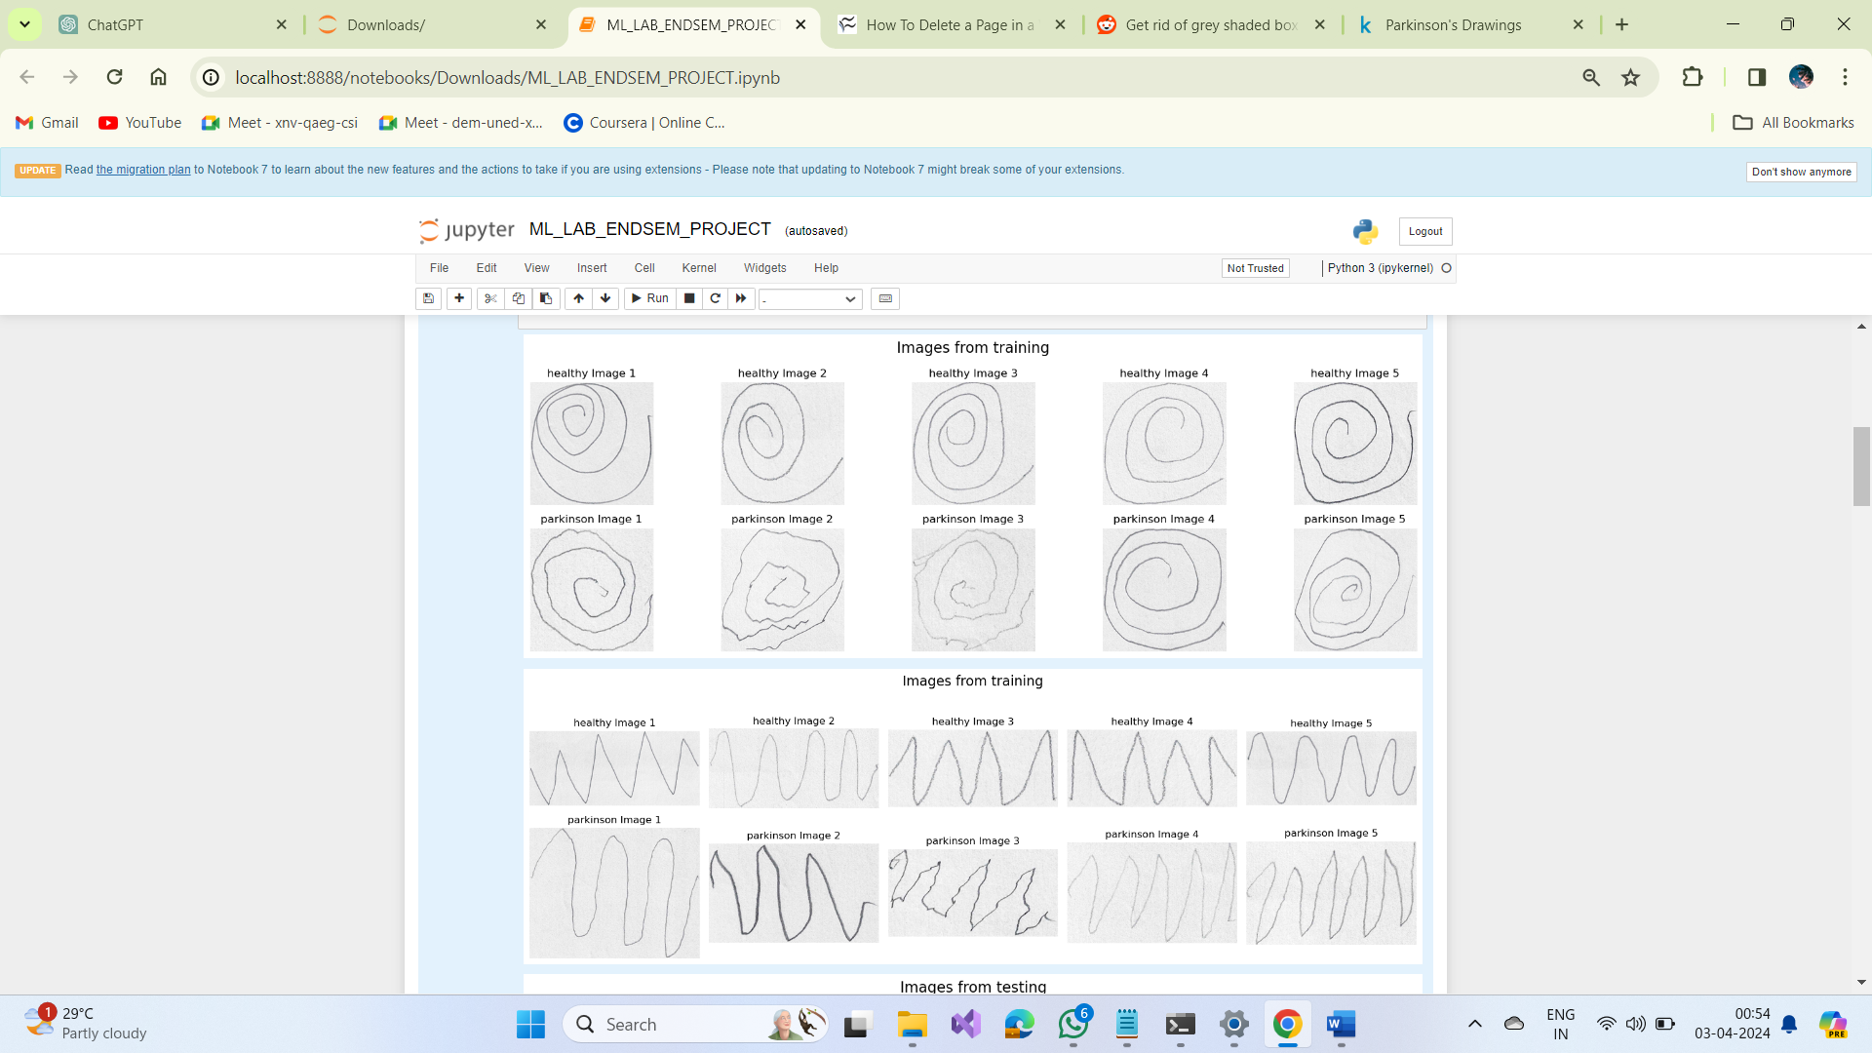

- Datasets Source:
  - Kaggle datasets provide a centralized repository of publicly available datasets spanning various domains, including computer vision, natural language processing, and tabular data analysis.

  - The data came from the paper: Zham P, Kumar DK, Dabnichki P, Poosapadi Arjunan S and Raghav S (2017) Distinguishing Different Stages of Parkinson’s Disease Using Composite Index of Speed and Pen-Pressure of Sketching a Spiral. Front. Neurol. 8:435. doi: 10.3389/fneur.2017.00435
- Dataset Description:

  - Images of healthy and patients with Parkinsons drawing spirals and waves. The images are further divided into training and testing groups for comparing (or reproducing) the results of the original publication
  - The dataset containing images of spiral and wave drawings was selected based on its relevance to our classification task and availability of labelled data for supervised learning.

- Dataset Characteristics:

  - It is annotated with labels indicating the class (spiral or wave) to which each image belongs, enabling supervised learning algorithms to learn the underlying patterns and features associated with each class.

CHAPTER 5
RESULT AND DISCUSSION

We assess the performance of various machine learning models in classifying spiral and wave drawings. We compare the accuracy of different models and discuss their strengths and limitations.
- Naive Bayes Classifier:
  - Best Alpha: 0.1
  - Spiral Naive Bayes Classification Accuracy: 76.67%
  - Wave Naive Bayes Classification Accuracy: 70.00%
- Random Forest Classifier:
  - Spiral Random Forest Classification Accuracy: 76.67%
  - Wave Random Forest Classification Accuracy: 70.00%
- K-Nearest Neighbours (KNN) Classifier:
  - KNN Classifier Accuracy: 83.33%
- Support Vector Machine (SVM) Classifier:
  - SVM Classifier Accuracy: 73.33%
- Voting Classifier:
  - Voting Classifier Accuracy: 80.00%
- The results reveal that the KNN classifier achieved the highest accuracy among the individual models, while the Naive Bayes classifier exhibited relatively lower performance. The Voting Classifier, which combines predictions from multiple models, achieved a competitive accuracy score, outperforming some individual classifiers.
- Overall, the KNN classifier demonstrates superior performance in distinguishing between spiral and wave drawings, followed closely by the Voting Classifier. However, the choice of the most suitable model depends on various factors such as computational efficiency, interpretability, and the specific requirements of the classification task.

CONCLUSION

In conclusion, our journey through evaluating different machine learning models for classifying spiral and wave drawings has provided valuable insights into their performance and applicability. Through meticulous experimentation and analysis, we have arrived at several key findings:
- Model Performance: Among the models evaluated, the K-Nearest Neighbours (KNN) classifier emerged as the top performer, achieving the highest accuracy in distinguishing between spiral and wave drawings. Its simplicity and effectiveness in capturing local patterns in the data contributed to its superior performance.
- Ensemble Learning: The Voting Classifier, which combines predictions from multiple models, demonstrated competitive accuracy, outperforming some individual classifiers. This underscores the effectiveness of ensemble learning techniques in improving classification accuracy through model aggregation.
- Algorithmic Complexity: The performance of each model varied based on its algorithmic complexity, hyperparameter settings, and suitability for the given dataset. While some models exhibited high accuracy, others showed room for improvement, highlighting the importance of selecting the most appropriate model for the task at hand.
- Future Directions: Moving forward, there are several avenues for further optimization and refinement of the classification framework. This includes fine-tuning hyperparameters, exploring ensemble learning strategies, and incorporating advanced feature extraction techniques to enhance model performance and robustness.
In essence, our study underscores the importance of systematic evaluation and comparison of machine learning models to identify the most effective approach for a given classification task. By leveraging the strengths of different models and techniques, we can develop robust and reliable classification systems capable of accurately distinguishing between complex visual patterns. As we continue to advance our understanding and methodologies in machine learning, the possibilities for real-world applications and impact are boundless.

REFERENCES

- https://scikit-learn.org/

- https://www.kaggle.com/datasets/kmader/parkinsons-drawings/data

- https://www.frontiersin.org/articles/10.3389/fneur.2017.00435/fullhttps://docs.opencv.org/4.x/d9/df8/tutorial_root.html

- https://docs.opencv.org/4.x/d9/df8/tutorial_root.html

- https://filipedsprocopio.medium.com/machine-learning-method-without-cnn-to-regonize-cats-and-dogs-11cd7136efe

- https://www.analyticsvidhya.com/blog/2021/07/step-by-step-guide-for-image-classification-on-custom-datasets/

